TOPIC 6: FRICTION
OBJECTIVES:
At the end of this class, students should be able to:
- Define friction
- Describe the different types of friction
- State the laws of friction.
- List the advantages and disadvantages of friction.

CONTENT
- When a body is set in motion on a particular surface at a particular velocity, it is supposed to move at that velocity continually until it is blocked but eventually it comes to a stop after moving for a while. Why did it come to a stop?
- It comes to a stop because there is a certain resistive force offered by the surface to the motion of the body. This force is what we describe as friction.
- Friction is a force that prevents a surface from moving freely over another surface.

Types of Friction
There are basically two types of friction which includes:
- STATIC FRICTION:
- This is the friction between two surfaces when the surfaces are at rest.
- It opposes every applied force tending to set the body in motion as shown below.

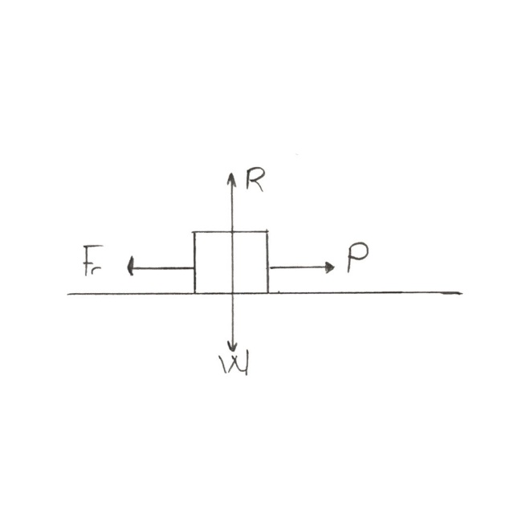

P: applied force
$F_{r}:$frictional force
$W:$ weight of the body
$R:$ normal reaction.
- $F_{r}$ increases as P is increased provided the body is yet to move.
- The minimum applied force needed to move the body is the same as the maximum static friction between the surfaces also known as “limiting friction.”
- DYNAMIC / KINETIC FRICTION:
- This is the frictional force that opposes a moving body.
- It is directed opposite to the direction of motion not necessarily the applied force.
- If the body slides on the surface, then the friction is called “sliding friction”.
- If the body rolls on the surface, then it is called “rolling friction”.
- Sliding friction is usually greater than rolling friction.
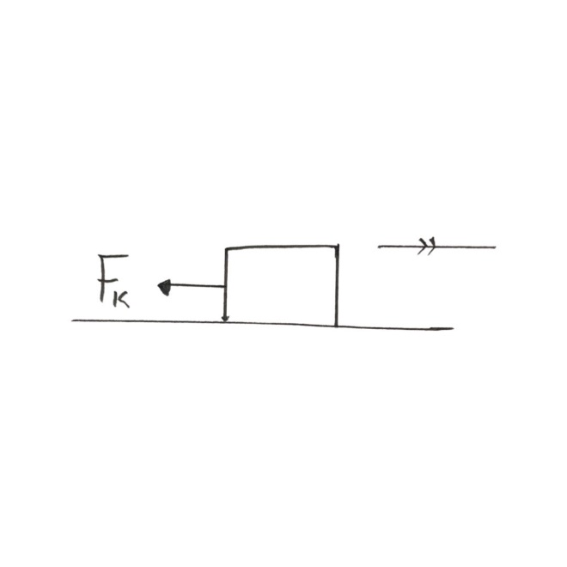

Note: there is also friction between layers of fluid, this is referred between layers of fluid, this is referred to as “Viscous Drag”.
LAWS OF FRICTION
- Friction opposes motion
- Frictional force is directly proportional to normal reaction. i.e. $F_{r}∝R.$
$$F_{r}=μR$$
$$F_{r}=frictional force$$
R = normal reaction
$μ=coefficient of friction$
- Frictional force depends on the nature of the surfaces in contact. The rougher the surfaces, the higher the friction.
- Frictional force does not depend on the area of the surfaces in contact.
- Frictional force does not depend on the relative motion of the surfaces in contact.
Note: the coefficient of static friction $μ_{s}$ is always higher than the coefficient of kinetic friction ($μ_{k}) between$two particular surfaces.
ADVANTAGES OF FRICTION
- It enables us to walk.
- It helps to support ladder against a wall.
- Friction between tires and road makes breaking possible.
- It helps in the transfer of energy.
- It helps in making fire.
DISADVANTAGES OF FRICTION
- It reduces efficiency of a machine.
- It causes wear and tear of machine.
- It causes heating effect.
METHODS OF REDUCING FRICTION
There are basically three methods of reducing friction:
- Lubrication:
- Application of lubricant to a surface reduces the effect of friction.
- The effect of friction in a dry surface is reduced when the surface is wet.
- Use of ball bearing and rollers.
- Streamlining the body is another way of reducing friction.

CALCULATIONS IN FRICTION
- A horizontal force of magnitude 20N is applied on a body of mass 30kg. if the coefficient of static friction between the body and the horizontal surface is 0.2
- Will the body be set in motion?
- What is the frictional force between the surfaces (Take g= 10m/$s^{2}$)

SOLUTION
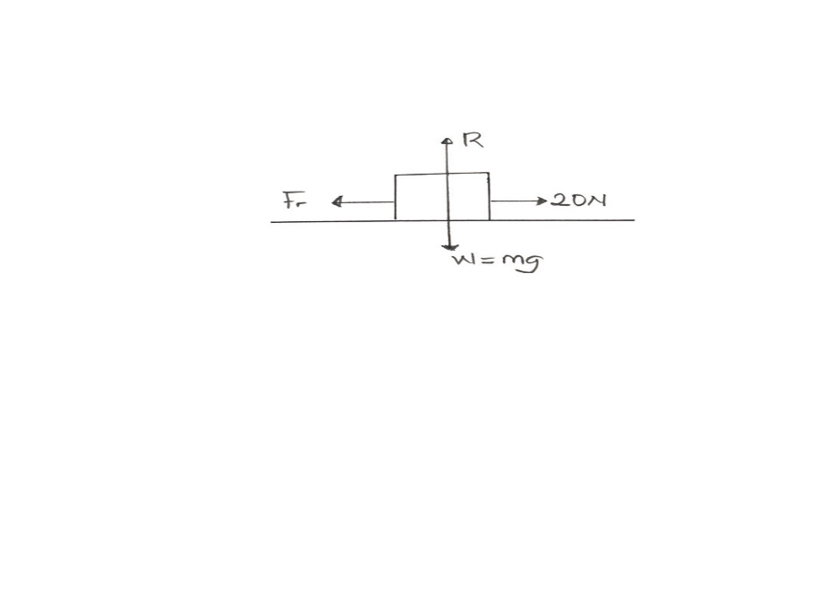

No motion along the vertical axis: R=mg
From laws of friction:
$$F_{r}=μR$$
$F_{s}=μ_{s}R$ = $μ_{s}mg$
$$μ_{s}=0.2, m=30kg, g=10m/s^{2}$$
$F_{s}=0.2 ×30×10$ = 60N
    - Applied force is less than limiting friction; hence, there will be no motion.
    - As long as there is no motion: $F_{r}=p$ therefore, $F_{r}=20$N
- Calculate the minimum horizontal force needed to move a body of mass 5kg along a surface of coefficient of static friction 0.5.


$$P_{min}= F_{s}$$
$=μ_{s}R$
$$= μ_{s}mg$$
$=0.5 ×5×10$ = 25N

FRICTION ON AN INCLINED PLANE
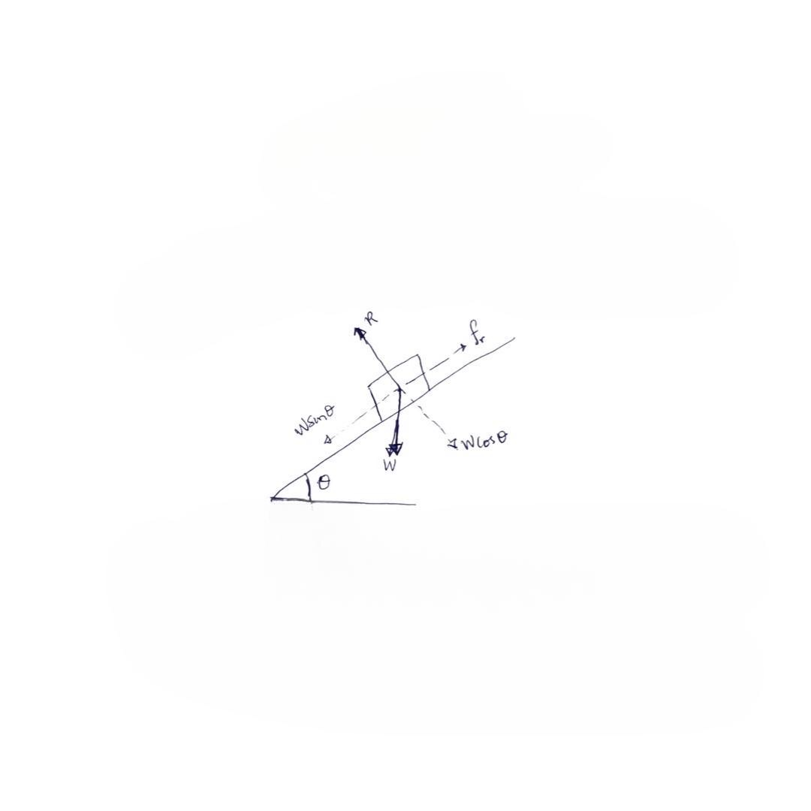

- Consider a body of mass, m, on a plane inclined at $θ$to the horizontal.
- The forces on the body are shown in the diagram.
- At the point the body is just about sliding down the plane (wsin$θ= F_{r}$)
- Friction law:$F_{s}=μ_{s}R$ i.e. Wsin$θ=μ_{s}R$
- No motion along the perpendicular axis to the plane, hence, R= Wcos$θ.$
- Thus, $wsinθ= μ_{s}(wcosθ)$
$$μ_{s}=\frac{wsinθ}{wcosθ}= tanθ$$

Where $θ$ is the minimum angle of inclination needed for the body to slide down freely?
REQUIREMENT:
- A plank to serve as a plain surface.
- A small rectangular block to serve as a body.
- A small rectangular wooden block with rollers under it.
DRILL
- Sliding friction is ___________ than / to rolling friction.
- smaller
- greater
- equal
- none of the above
- Four children were asked to arrange forces due to rolling, static and sliding frictions in an increasing order. Their arrangements are given below. Choose the correct arrangement.
- Rolling, static, sliding
- Static, rolling, standing
- Rolling, sliding, static,
- Sliding, static, rolling
- It is difficult to walk on oily floor because
- Floor gets spoiled
- There is more resistance
- Force of friction is high
- Force of friction is low.
- Which of the following materials is likely to have the least friction?
- Wood
- Cardboard
- Glass
- Paper
- What is the value of the sliding friction for an object which requires 7N of force to move it from rest?
- 7N
- Greater than 7N
- Less than 7N
- 14N

